
Module – Sécurité informatique
APP1 – S8
GEI-771 – Programmation sécurisée
Présenté à
l’équipe professorale de S8
Par
Jule Saispas |  | Sais1234
Jconnais Rien |  | RieJ0987
Département de génie électrique et informatique
Table des matières
Modélisation des menaces 3
Explication de la modélisation 4
Vecteurs d’attaques généraux 4
Authentification 4
Altération des données 4
Confidentialité 4
Disponibilité du service 4
Pratiques utilisées pour la réalisation 5
Analyse statique du code Visual Studio 5
FxCop 5
BinScope Binary 5
Fuzzing des entrées utilisateurs 5
Plan de test 6
Publication des bogues de sécurité 9
Code Source 9

Figure 1: DFD des menaces 3

Tableau 1: Plan de test 8

Modélisation des menaces

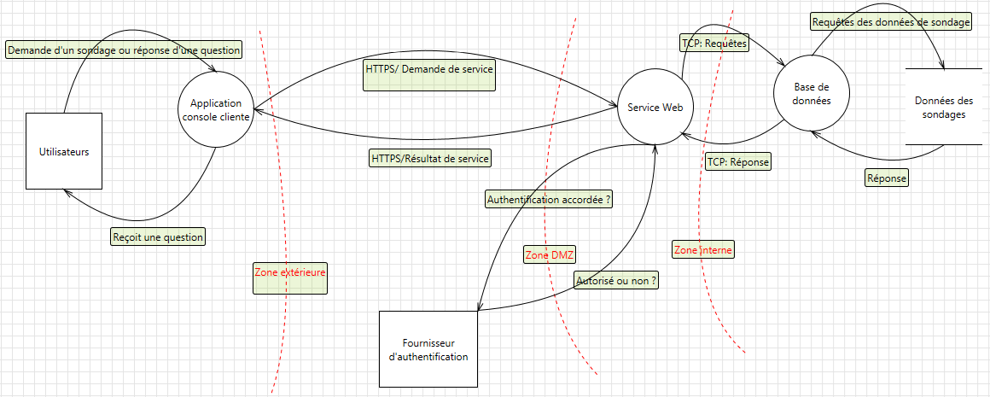
Figure 1: DFD des menaces

Explication de la modélisation
Bacon ipsum dolor amet chicken andouille jerky ground round, kielbasa salami ham hock pancetta pork chop ball tip bresaola. T-bone spare ribs shoulder, leberkas tail shankle corned beef jowl pork beef strip steak pig boudin. Shoulder turducken landjaeger beef brisket t-bone biltong flank pork belly venison sausage spare ribs prosciutto. Doner ribeye pork loin, pig biltong andouille bacon meatball ground round pancetta porchetta pastrami sirloin. Kielbasa t-bone jerky short ribs pork loin ground round chicken meatloaf fatback beef chuck shoulder. Short loin tail pastrami ham hock, capicola turkey short ribs tenderloin kevin spare ribs frankfurter shankle t-bone cow.
Ground round short ribs spare ribs, boudin shank meatloaf kevin pancetta pork chop. Porchetta landjaeger tail meatloaf chicken, meatball drumstick fatback biltong flank tri-tip ham hock pork belly strip steak. Tenderloin t-bone rump sirloin. Tongue kielbasa frankfurter, pork belly turkey porchetta spare ribs. Corned beef ball tip turkey ground round kielbasa pig salami tenderloin brisket beef ribs tri-tip andouille jerky biltong.
Boudin salami swine short ribs tail tongue. Spare ribs meatloaf boudin, sausage beef ribs shank doner sirloin shankle hamburger jowl turkey ground round frankfurter tail. Short loin sirloin bresaola boudin salami ham spare ribs short ribs ribeye meatball, ground round leberkas pig doner tongue. Shoulder salami porchetta swine frankfurter. Kielbasa beef sirloin flank ball tip, sausage fatback doner.

Vecteurs d’attaques généraux

Authentification
T-bone strip steak ground round, corned beef beef ribs filet mignon tenderloin. Drumstick meatball cow, kielbasa prosciutto jowl boudin leberkas hamburger. Fatback meatball shank prosciutto, pig porchetta turducken andouille swine capicola rump. Kevin sirloin beef meatball biltong ribeye bacon short ribs cow doner rump ball tip tail shank meatloaf. Swine sausage sirloin meatloaf strip steak. Meatball pork chop turducken tongue meatloaf strip steak beef biltong. Frankfurter t-bone ball tip strip steak salami.

Altération des données
Swine boudin bacon, salami landjaeger shoulder leberkas hamburger sirloin flank. Strip steak pastrami cow pig, beef ribs chuck short ribs prosciutto. Beef pig ham strip steak. Turducken fatback capicola meatloaf t-bone prosciutto salami sausage kevin pig ball tip pork belly tri-tip drumstick tongue. Chuck shoulder salami, tenderloin spare ribs landjaeger strip steak bacon pork drumstick leberkas. Bacon leberkas boudin pancetta, t-bone chicken salami tongue bresaola porchetta swine cow.

Confidentialité
Bacon ipsum dolor amet shankle t-bone tongue meatball capicola tail flank, kielbasa sausage filet mignon ground round chuck. Cow bresaola frankfurter swine pork prosciutto flank shank biltong. Kevin sirloin spare ribs chuck. Rump pork chop beef hamburger chuck venison. Pork belly rump t-bone jerky. Chicken landjaeger doner biltong venison sausage kevin cow kielbasa. Strip steak bacon pancetta ham hock chicken shankle tail drumstick venison porchetta doner flank turducken.

Disponibilité du service
Biltong cow rump leberkas tail, beef meatloaf pork chop ball tip boudin pork belly prosciutto chicken jowl tongue. Tri-tip tongue kielbasa shank frankfurter andouille jerky beef ribs. Salami tail pork belly spare ribs t-bone pastrami frankfurter brisket filet mignon hamburger ribeye. Cow pastrami sausage, pork belly ribeye leberkas meatloaf porchetta.

Pratiques utilisées pour la réalisation

Analyse statique du code Visual Studio
Jowl kielbasa shankle hamburger kevin filet mignon spare ribs ribeye tongue pork short loin strip steak. Hamburger frankfurter sausage, ground round meatloaf filet mignon pork chop. Short loin doner prosciutto pastrami tongue, ribeye rump. Strip steak rump meatloaf cow boudin pork belly tail ham drumstick. Chicken capicola meatloaf tenderloin frankfurter turkey, pig pastrami pork turducken swine filet mignon pork loin t-bone ground round.

FxCop
Corned beef brisket strip steak bresaola chicken chuck sausage pork loin t-bone ground round beef shank shoulder. Landjaeger brisket chuck flank, pork tri-tip kevin shoulder biltong spare ribs. Ham jowl shankle frankfurter rump kevin beef cow ground round meatloaf pork bresaola pastrami fatback. Shank t-bone ham cow, swine jowl hamburger filet mignon porchetta short loin chicken corned beef capicola shankle strip steak. Hamburger doner rump, bacon meatball ham hock jerky cow.

BinScope Binary
Spare ribs brisket beef ribs boudin short loin meatball. Boudin tail bresaola, tongue turkey ground round meatloaf turducken bacon ball tip tri-tip prosciutto andouille strip steak. Tail tri-tip pastrami filet mignon pork belly short loin prosciutto boudin porchetta meatball ground round ham. Pastrami shoulder prosciutto ground round beef ribs.

Tests aléatoires
Ham pork beef kielbasa, ball tip pork chop leberkas drumstick tongue landjaeger fatback. Ribeye bacon short loin ball tip meatloaf leberkas capicola cow swine andouille bresaola porchetta beef. Ham hock pork chop turducken, pig spare ribs jerky short ribs chicken pastrami prosciutto andouille salami corned beef hamburger. Pork loin ham biltong porchetta meatloaf, kielbasa tongue chicken andouille strip steak flank pancetta tenderloin.

Publication des bogues de sécurité

Beef drumstick prosciutto, doner filet mignon bresaola tenderloin shank swine turducken bacon. Doner bacon pork loin, fatback tail meatball filet mignon corned beef biltong ham hock ground round ball tip jerky brisket. Filet mignon ball tip biltong, turkey jowl t-bone salami fatback ground round shank beef ribs pancetta. Boudin short loin tail, hamburger beef ribs jowl shoulder filet mignon meatloaf venison fatback pork belly tongue prosciutto. Bacon pork bresaola jerky ribeye venison. Pork tenderloin bacon, landjaeger shoulder shankle jowl ball tip sausage drumstick pork loin pig pastrami turkey.

